EXP-2

Aim:- To study and implement version control, Install git

Theory:-

Version control is a system that records changes to a file or set of files over time so that you can recall specific versions later. For the examples in this book, you will use software source code as the files being version controlled, though in reality you can do this with nearly any type of file on a computer.

The various types of the version control systems are:

1. Local version control system
2. Centralized version control system
3. Distributed version control system
4. Local version control system: Local version control system maintains track of

Files within the local system. This approach is very common and simple. This

Type is also error prone which means the chances of accidentally writing

To the wrong file is higher.

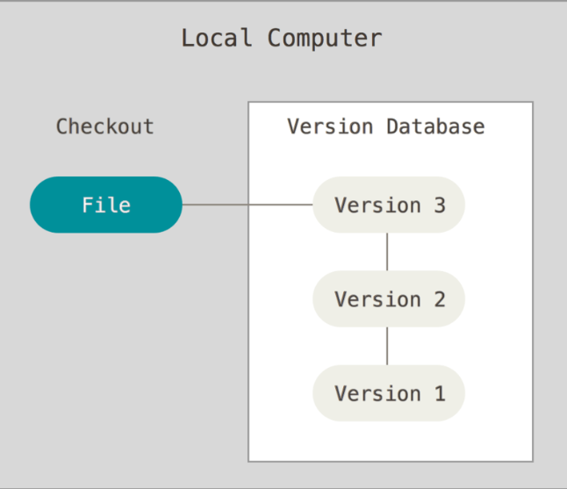

2]. Centralized version control system: In this approach, all the changes in the

Files tracked unded the centralized server. The centralized server includes all the information of versioned files, and list of clients that check out files from that central place.

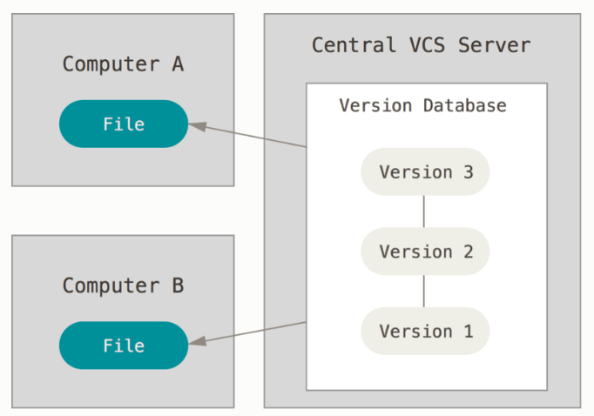

**Distributed Version Control Systems**

This is where Distributed Version Control Systems (DVCSs) step in. In a DVCS (such as Git, Mercurial or Darcs), clients don’t just check out the latest snapshot of the files; rather, they fully mirror the repository, including its full history. Thus, if any server dies, and these systems were collaborating via that server, any of the client repositories can be copied back up to the server to restore it. Every clone is really a full backup of all the data.

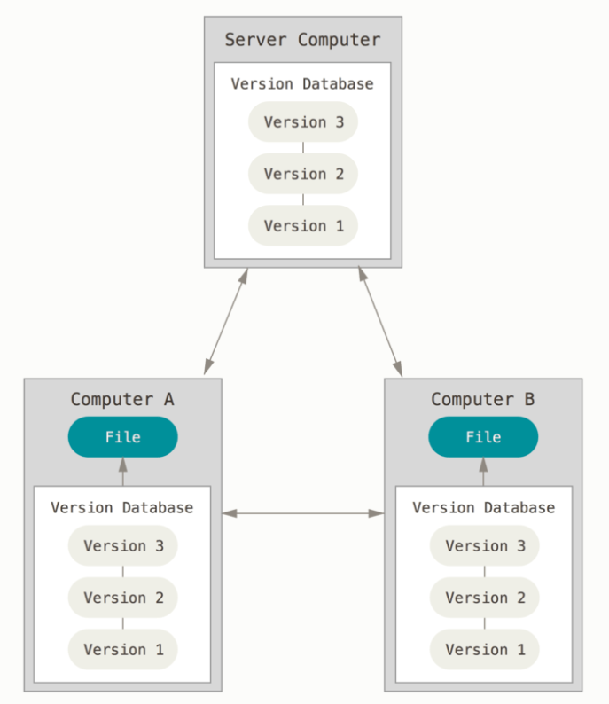

Installing git:-

Before you start using Git, you have to make it available on your computer. Even if it’s already installed, it’s probably a good idea to update to the latest version. You can either install it as a package or via another installer, or download the source code and compile it yourself.

**Installing on Windows**

There are also a few ways to install Git on Windows. The most official build is available for download on the Git website. Just go to <https://git-scm.com/download/win> and the download will start automatically. Note that this is a project called Git for Windows, which is separate from Git itself; for more information on it, go to [https://gitforwindows.org](https://gitforwindows.org/).

**Installing on macOS**

There are several ways to install Git on macOS. The easiest is probably to install the Xcode Command Line Tools. On Mavericks (10.9) or above you can do this simply by trying to run git from the Terminal the very first time.

$ git --version

If you don’t have it installed already, it will prompt you to install it.

If you want a more up to date version, you can also install it via a binary installer. A macOS Git installer is maintained and available for download at the Git website, at <https://git-scm.com/download/mac>.

Conclusion:-

Thus, we have successfully studied version control and installed git.